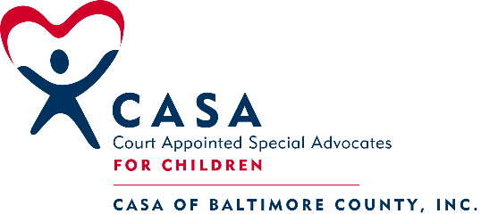
305 W. Chesapeake Ave. Suite 117
Towson, MD 21204
Phone (410) 828-0515, Fax (410) 828-0517

MARCH/APRIL 2019 PRE-SERVICE TRAINING SCHEDULE

Session # 1: Introduction to the CASA Volunteer Role
Monday, March 4, 2019; 6 PM to 9 PM
Location: CASA Office Jennifer Stine, Facilitator

Session # 2: The Well-Being of the Child
Thursday, March 7, 2019; 6 PM to 9 PM
Location: CASA Office Renee Richard, Facilitator

Session # 3: Trauma, Resilience and Communication Skills
Monday, March 11, 2019; 6 TO 9 P.M
Location: CASA Office Joanne Lindsay, Facilitator

Session # 4: Mental Health, Poverty and Professional Communication
Thursday, March 14, 2019; 6 PM to 9 PM
Location: CASA Office Anne Feehley, Facilitator

Session # 5: Substance Abuse and Cultural Competence
Thursday, March 21, 2019; 6 PM to 9 PM
Location: CASA Office Karen Coleman, Facilitator

Session #6: Domestic Violence and Cultural Competence
Monday, March 25, 2019; 6PM to 9 PM.
Location: CASA Office Lucretia Scott, Facilitator

Session #7: Educational Advocacy, Older Youth and LGBTQ Youth
Thursday, March 28, 2019; 6 PM to 9 PM
Location: CASA Office Sarah Atherton, Facilitator

Session # 8: Safety, Review and Panel
Monday, April 1, 2019; 6 PM to 9 PM.
Location: CASA Office Facilitator TBD

Session # 9: Wrapping Up
Thursday, April 4, 2019; 6 PM to 9 PM
CASA Office Dan McEachran, Facilitator

ALL SESSIONS WILL REQUIRE PRE-WORK TO BE COMPLETED PRIOR TO THE SESSION DATE
***All applicants must observe a half-day Court docket – Dates scheduled during class
***Swearing-In Ceremony: Date TBD

Fostering Futures Training: Dan McEachran, Facilitator Date TBD

CASA APPLICANTS MUST ATTEND ALL SESSIONS AS SCHEDULED.
IN CASE OF INCLEMENT WEATHER, CASA OF BALTIMORE COUNTY WILL FOLLOW CLOSINGS FOR BALTIMORE COUNTY SCHOOLS. ANY CANCELED TRAININGS WILL BE RESCHEDULED.

