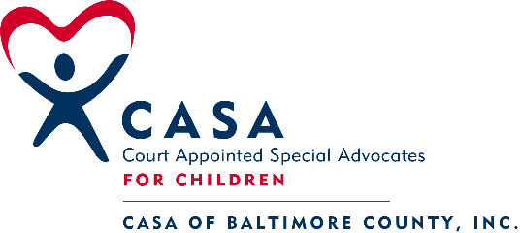
305 W. Chesapeake Ave. Suite 117
Towson, MD 21204
Phone (410) 828-0515, Fax (410) 828-0517

MAY 2019 PRE-SERVICE TRAINING SCHEDULE

Session # 1: Introduction to the CASA Volunteer Role
Thursday, May 2, 2019; 6 PM to 9 PM
Location: CASA Office Jennifer Stine, Facilitator

Session # 2: The Well-Being of the Child
Tuesday, May 7, 2019; 6 PM to 9 PM
Location: CASA Office Renee Richard, Facilitator

Session # 3: Trauma, Resilience and Communication Skills
Thursday, May 9, 2019; 6 TO 9 P.M
Location: CASA Office Joanne Lindsay, Facilitator

Session # 4: Mental Health, Poverty and Professional Communication
Tuesday, May 14, 2019; 6 PM to 9 PM
Location: CASA Office Anne Feehley, Facilitator

Session # 5: Substance Abuse and Cultural Competence
Thursday, May 16, 2019; 6 PM to 9 PM
Location: CASA Office Karen Coleman, Facilitator

Session #6: Domestic Violence and Cultural Competence
Tuesday, May 21, 2019; 6PM to 9 PM.
Location: CASA Office Lucretia Scott, Facilitator

Session #7: Educational Advocacy, Older Youth and LGBTQ Youth
Thursday, May 23, 2019; 6 PM to 9 PM
Location: CASA Office Sarah Atherton, Facilitator

Session # 8: Safety, Review and Panel
Tuesday, May 28, 2019; 6 PM to 9 PM.
Location: CASA Office Lisa Turner, Facilitator

Session # 9: Wrapping Up
Thursday, May 30, 2019; 6 PM to 9 PM
CASA Office Dan McEachran, Facilitator

ALL SESSIONS WILL REQUIRE PRE-WORK TO BE COMPLETED PRIOR TO THE SESSION DATE
***All applicants must observe a half-day Court docket – Dates scheduled during class
***Swearing-In Ceremony: Date TBD

Fostering Futures Training: Dan McEachran, Facilitator
Offered four times during the year. Required for CASAs working with youth ages 14+

CASA APPLICANTS MUST ATTEND ALL SESSIONS AS SCHEDULED.
IN CASE OF INCLEMENT WEATHER, CASA OF BALTIMORE COUNTY WILL FOLLOW CLOSINGS FOR BALTIMORE COUNTY SCHOOLS. ANY CANCELED TRAININGS WILL BE RESCHEDULED.

