How to Explanation for ZOOM
How to Download Zoom on your computer
- Open your computer's internet browser and go to the Zoom website at Zoom.us.
- Scroll down to the bottom of the page and click "Download" in the web page's footer.
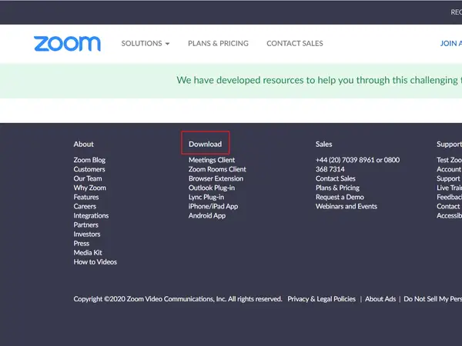
- On the Download Center page, click "Download" under the "Zoom Client for Meetings" section.
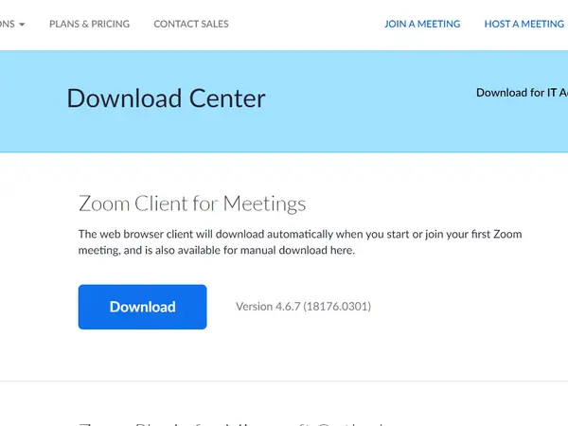
- The Zoom app will then begin downloading.

How to share a Whiteboard on Zoom
- Click the Share Screen button located in your meeting toolbar.
- Click Whiteboard.
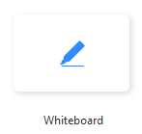
- Click Share.
- The annotation tools will appear automatically, but you can press the Whiteboard option in the meeting controls to show and hide them.
- Use the page controls in the bottom-right corner of the whiteboard to create new pages and switch between pages.
Note: Only the participant or host that started sharing the whiteboard has access to create and switch pages. But the participants and the host should all be able to draw on the whiteboard.
- When you are done, click Stop Share.

