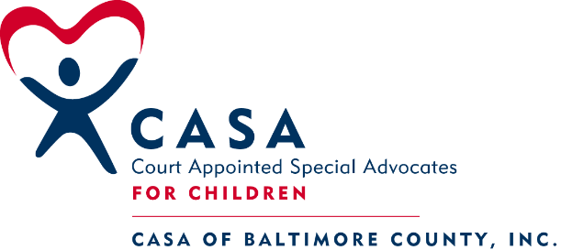
305 West Chesapeake Ave. Suite 117
Towson, MD 21204
410- 828-0515

CASA COURT REPORT

Reporting Period from:
CASA Name: CASA Appointment Date:
Court Hearing Date:
Date CASA report completed:

Child’s Name: Docket Number: Date of Birth:

- CASA ACTIVITIES

RECORDS REVIEWED: DSS Court Reports, CASA visitation documents, School Records

CHILD CONTACTS: During this review period, I have had 6 visits with Kate, two of which were the CASA picnic and the CASA Holiday Party. All other visits were at the home of her foster parents.

FAMILY CONTACTS: I have had several face-to-face contacts with Kate’s aunt.

COLLATERAL CONTACTS: I have had regular contact with Kate’s DSS social worker and attorney. I have also spoken with her school counselor.

- FINDINGS

1. BACKGROUND INFORMATION:

A. REASON CHILD CAME INTO CARE: On (Date) the Department sheltered Kate due to significant safety concerns related to physical abuse and neglect. Kate was declared CINA on (Date)
B. PLACEMENT HISTORY:
Foster home of (Foster parents’ name) Date:
Foster home of (Current Foster parents) Date:
2. EDUCATIONAL ISSUES: Kate is doing well in school. She makes good grades and likes learning. She enjoys art class and is a talented artist.

3. MEDICAL ISSUES: Kate is in good health. All medical and dental appointments are up to date.

4. PSYCHOLOGICAL ISSUES: Kate meets regularly with her school counselor to discuss social / emotional issues. Kate does not have a psychiatric diagnosis.

5. FAMILY/SIBLING VISITATION: Kate does not have contact with her biological parents. She sees her aunt weekly.

6. CASA’S IMPRESSIONS OF THE CHILD: In the time that I have known Kate, I have found her to be pleasant and happy. She prefers to play by herself, but will join in with others. Kate appears very connected to her foster mom and foster sisters and seems to enjoy being part of this family. She has never spoken to me about her biological parents.

7. COURT STIPULATIONS
- Kate remains committed to the Department
- Permanency Plan continues to be reunification concurrent with placement with a relative for custody and guardianship
- Visits with aunt are liberal and unsupervised
- Visits with biological mother are liberal and supervised

8. PERMANENCY PLAN: Reunification concurrent with placement with a relative for custody and guardianship

9. CHILD’S WISHES: I have not specifically asked Kate what her wishes are, but she has expressed to me on several occasions that she is happy in her foster home and she feels well cared for and safe. She also enjoys visits with her aunt as well.

10. RECOMMENDATIONS:
- Continue commitment to Baltimore County Department of Social Services
- Continue with current placement
- Encourage Kate’s interest in art
- Continue this CASA Volunteer appointment

Respectfully submitted:

CASA Volunteer:________________________

CASA Supervisor:__________________________

